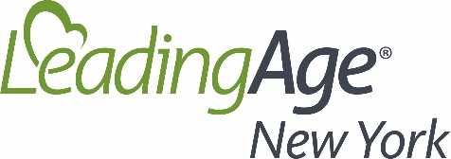

HR Council Meeting 5/5/2022

Introductions (E. Quinn)
Resettlement Agency, Buffalo area: Mike Helbringer, President/CEO (Bristol Homes)
- Recruitment issues – International Institute of Buffalo; acclimate refugees, facilitate settling and employment.
- Found process of hiring easier. Agency brought vetted people in for employment opportunities.
Recruitment toolkit from diversity committee – Ellen will add to the workforce page
Compensation conversation (Lisa Brown Alexander – Nonprofit HR)
- Does the organization offer a “healthy workplace culture/environment”? If healthy, positive, non-toxic etc.; employees are less likely to leave. Warmth Survey
- Compensation increases based upon inflation whenever possible. Minimum wage below $15 in high wage areas will not work. This should eb the minimum hourly rate for anyone!
- Look to other ‘communities’ for workforce: marginalized communities (have a level of readiness to include these people, learning and preparation by management)
- Extend greater levels of flexibility
- What are people saying about your organization as an employer? Google it and pay attention!
- What has been a successful step you have taken to build a more positive workforce culture?
- Appreciation efforts: picnics, raffles, ice cream, shout outs of appreciation, meal give aways, gift cards, monetary incentives to pick up shifts, holiday gift cards, section on website for employees to write comments, quarterly surveys to see employee feelings/issues and act on the results, daily huddles, get to know employees, paid holidays on birthdays, ensure new employees are being respected and are invited into organization.
- Look at where your organization is spending money? Is it on errors or injuries? If so, maybe people are not getting enough rest and recovery time. You can re-cover $ from your budget to pay staff more by investing in employees initially.
- Survey staff on what can we do better? Staff may have great ideas and feel heard. Recognition events. Do a “Stay interview” to find out why staff is staying and use their information to make changes. Realtime information before people leave! Have conversations with employees and implement change accordingly! Let the employee(s) know that you changed in response to their suggestions.
- Work on our culture/ our managers: Are they working compassionately with their employees?
- Remember: appreciation events are nice, but wage increases usually mean more to employees. (Cakes don’t pay for the gas in their car or buy groceries!)
Next Meeting: Discussion of cost of turnover; create a template to determine your facilities’ numbers. Ellen will add a tool to our website to calculate the cost of turnover.

